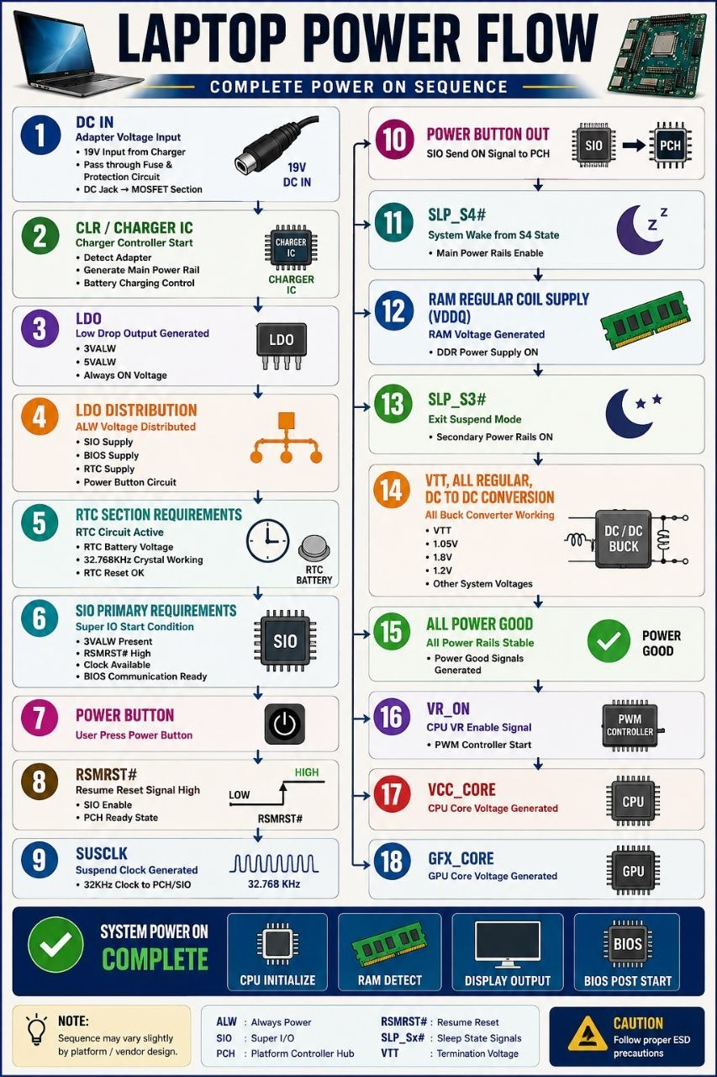

Laptop Power Flow
1. DC IN
- Adapter Power (19V)
2. Charger IC (CLR)
- DC Jack Voltage aur Charger IC VIN Voltage same honi chahiye.
3. LDO Generation, 3V / 5V Generation
- 3V/5V Controller IC (TPS51225, RT8243, etc.) 19V ko convert karke +3VALW aur +5VALW banata hai.
- 3V/5V PWM IC se LDO generate hoti hain.
- Common LDOs: 3.3V, 5V, 1.8V
Note:
Battery connector ki middle pins par 3.3V milna aksar LDO generation ka indication hota hai,
lekin sirf isi se LDO section ko 100% OK nahi mana jata.
4. LDO Distribution
- SIO / EC Supply
- BIOS Supply
- RTC Supply
- Power Button Circuit Supply
5. RTC Section Requirements
- RTC Battery Voltage Present
- 32.768 KHz Crystal Oscillating
- RTC_RST# OK
Note:
Agar 32.768 KHz crystal chal raha hai to RTC section partially active mana ja sakta hai.
Complete RTC working tab mani jayegi jab RTC logic se SUSCLK (32 KHz Clock) generate
hokar SIO/PCH ko receive ho rahi ho.

Random
Sequence practical repair point of view
19V DC IN
↓
Charger IC
↓
3.3V_ALW / 5V_ALW
↓
LDO Generation
↓
RTC Section
↓
SUSCLK
↓
EC/SIO Active

